
Lab Report 12
Data Communication & Computer Networks


Submitted To:
Engineer Shehzad Malik
Submitted By:
Sumama Rahim
F24BSCS039
BS CS (F24-A-Morning)
Date: 12/19/2025
LAB REPORT – 12
Cisco Packet Tracer – Configuring Speed of Different Interfaces

Topology:

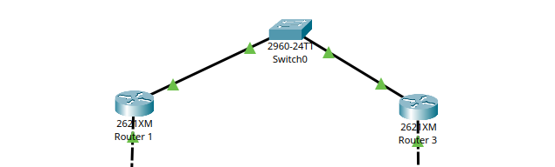

Task 1: Setting 100 Mbps speed for interface 0/1

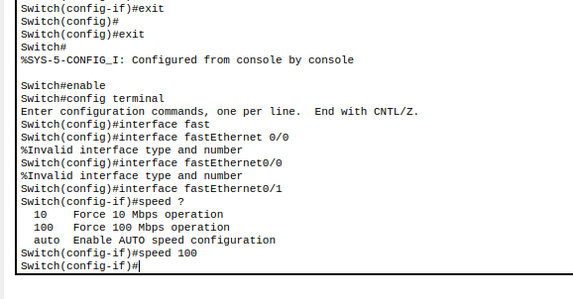
Verifying the Speed, in following the first line speed column shows that we set the speed of 100 Mbps operations for port: FastEthernet 0/1.

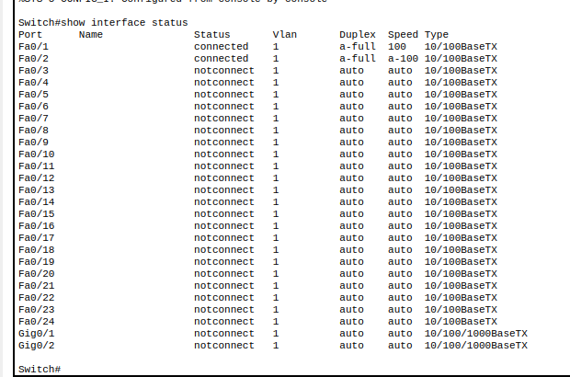

Task 2: Changing mode of an interface

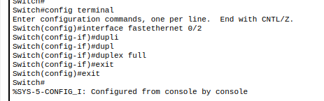

Checking:
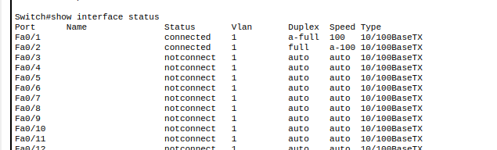

Task 3: Default VTP config value of a switch

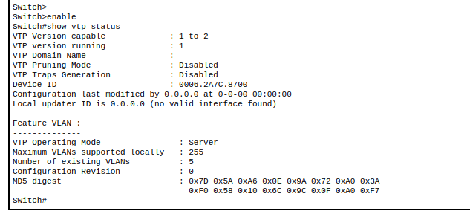
NOTE: Configuration revision : 0 means there is VLAN exists except default ones. By default there are 5 VLAN as we discussed in one of our previous labs. Currently VTP operating mode is set to Server and we can change it accordingly.

Task 4: Configuring VTP mode

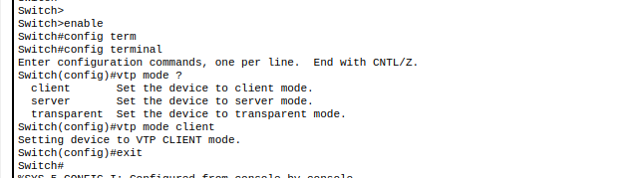

Task 5: Config VTP Domain

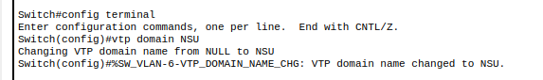
Task 6: Setting VTP Passwd

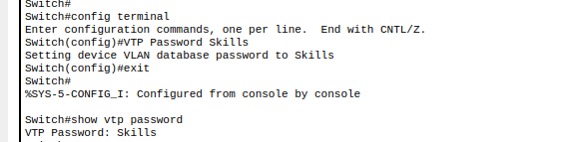

Task 7: Creating VLAN

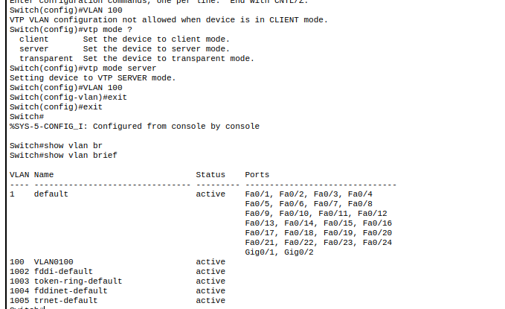
We can see the new VLAN has been created named VLAN 100
Task 8: Setting name of VLAN

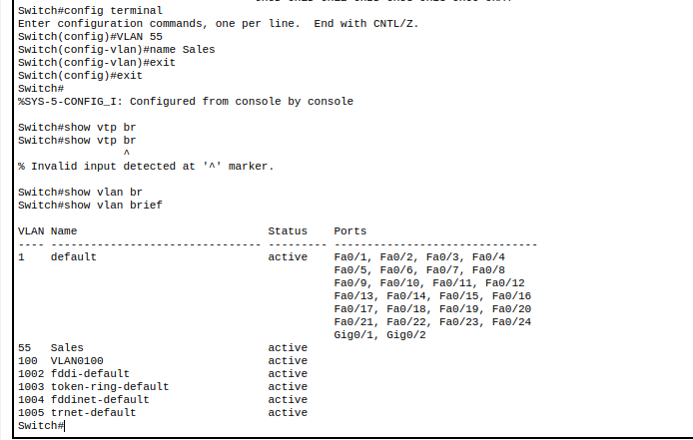

The End

